**EXERCISE: 5**

**DATE: 23.11.2020**

**AIM:**

To write a python function to print missing characters to make string program

**PROGRAM:**

**def pargram(s):**

**alpha="abcdefghijklmnopqrstuvwxyz"**

**a=[pa for pa in alpha if pa in s]**

**b=[npa for npa in alpha if npa not in s]**

**if(len(a)==26):**

**c2s = ''.join([str(elem) for elem in a])**

**return 'pangram'**

**else:**

**c2s = ''.join([str(elem) for elem in b])**

**return c2s**

**st=str(input())**

**st=st.lower()**

**p=pargram(st)**

**print(p)**

**LINK:**

<http://103.53.53.18/mod/vpl/forms/submissionview.php?id=235&userid=1664>

**OUTPUT:**

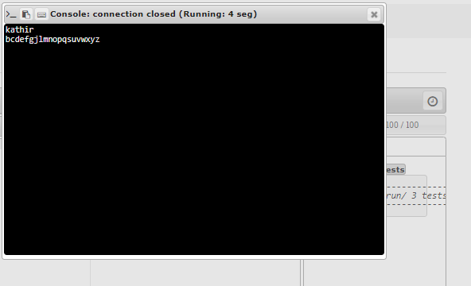

**RESULT:**

Thus the program is executed successfully